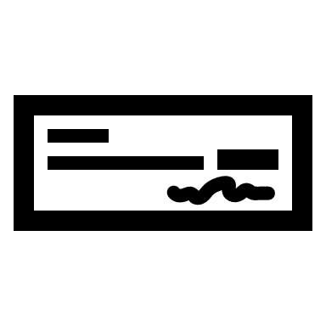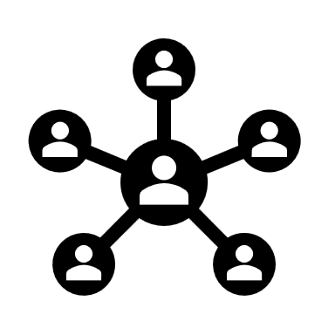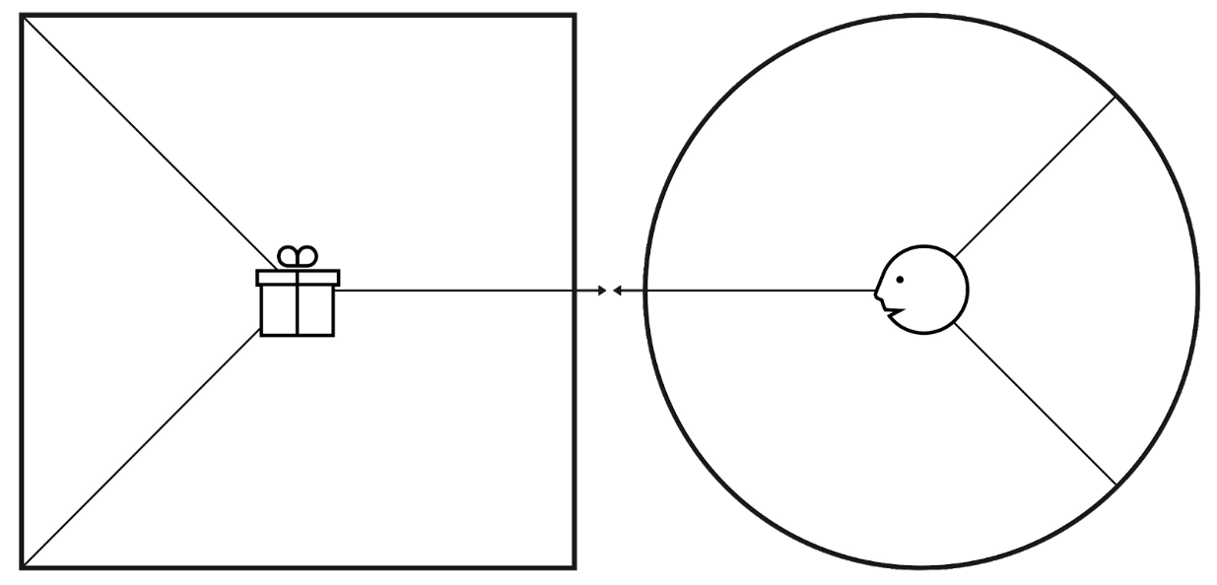VISUAL PROPOSITION MAP

Creators constantly check the reviews and look for a possible fix for the problems encountered.

Designer and costumer would take a personality test before entering the actual platform to see compatibility and preferences

Designers will send a proof that the designs shown are their own.

Must show that they are a professional designer

Dissatisfaction of designs

Communication problems  
can also be *Personality Differences* of the costumer and designer

Sample  
designs

Easy   
designer  
search

Easy details  
of designer

Easy location  
of designer

G A I N S C R E A T O R S

P A I N R E L I E V E R S

P R O D U C T S

&

S E R V I C E S

P A I N S

Better Resources and Contacts

Costumer’s house will have a “WOW” factor

Costumers will save time

G A I N S

Social

Functional

Emotional

Proper budgeting

J O B S